# TIPID: DECISION SUPPORT SYSTEM ON E-SHOPPING PRODUCTS THROUGH GRAPHICAL VISUALIZATION

A Thesis  
Presented to the Faculty of the  
College of Computer and Information Sciences  
Polytechnic University of the Philippines

In Partial Fulfilment of the Requirements for the Degree

Bachelor of Science in Computer Science

**Averos, Christian M.**

**Delicano, Jobea Ann F.**

March 2018

# AUTHORIZATION

I/We hereby declare that I am/We are the sole author/s of the thesis.

I/We authorize the Polytechnic University of the Philippines and the College of Computer and Information Sciences to lend this thesis to other institutions or individuals for the purpose of scholarly research.

I/We further authorize the Polytechnic University of the Philippines and the College of Computer and Information Sciences to reproduce the thesis by photocopying or by other means, in total or in part, at the request of other institutions or individuals for the purpose of scholarly research.

______________________________

Averos, Christian M.

______________________________

Delicano, Jobea Ann F.

March 2018

# AFFIDAVIT OF CO-OWNERSHIP

# CERTIFICATION OF PROOFREAD

This is to certify that the thesis work entitled “TIPid: Decision Support System on E-Shopping Products through Graphical Visualization” by Christian M. Averos and Jobea Ann F. Delicano was proofread and edited by the undersigned.

This Certification is being issued for whatever legal purpose it may serve.

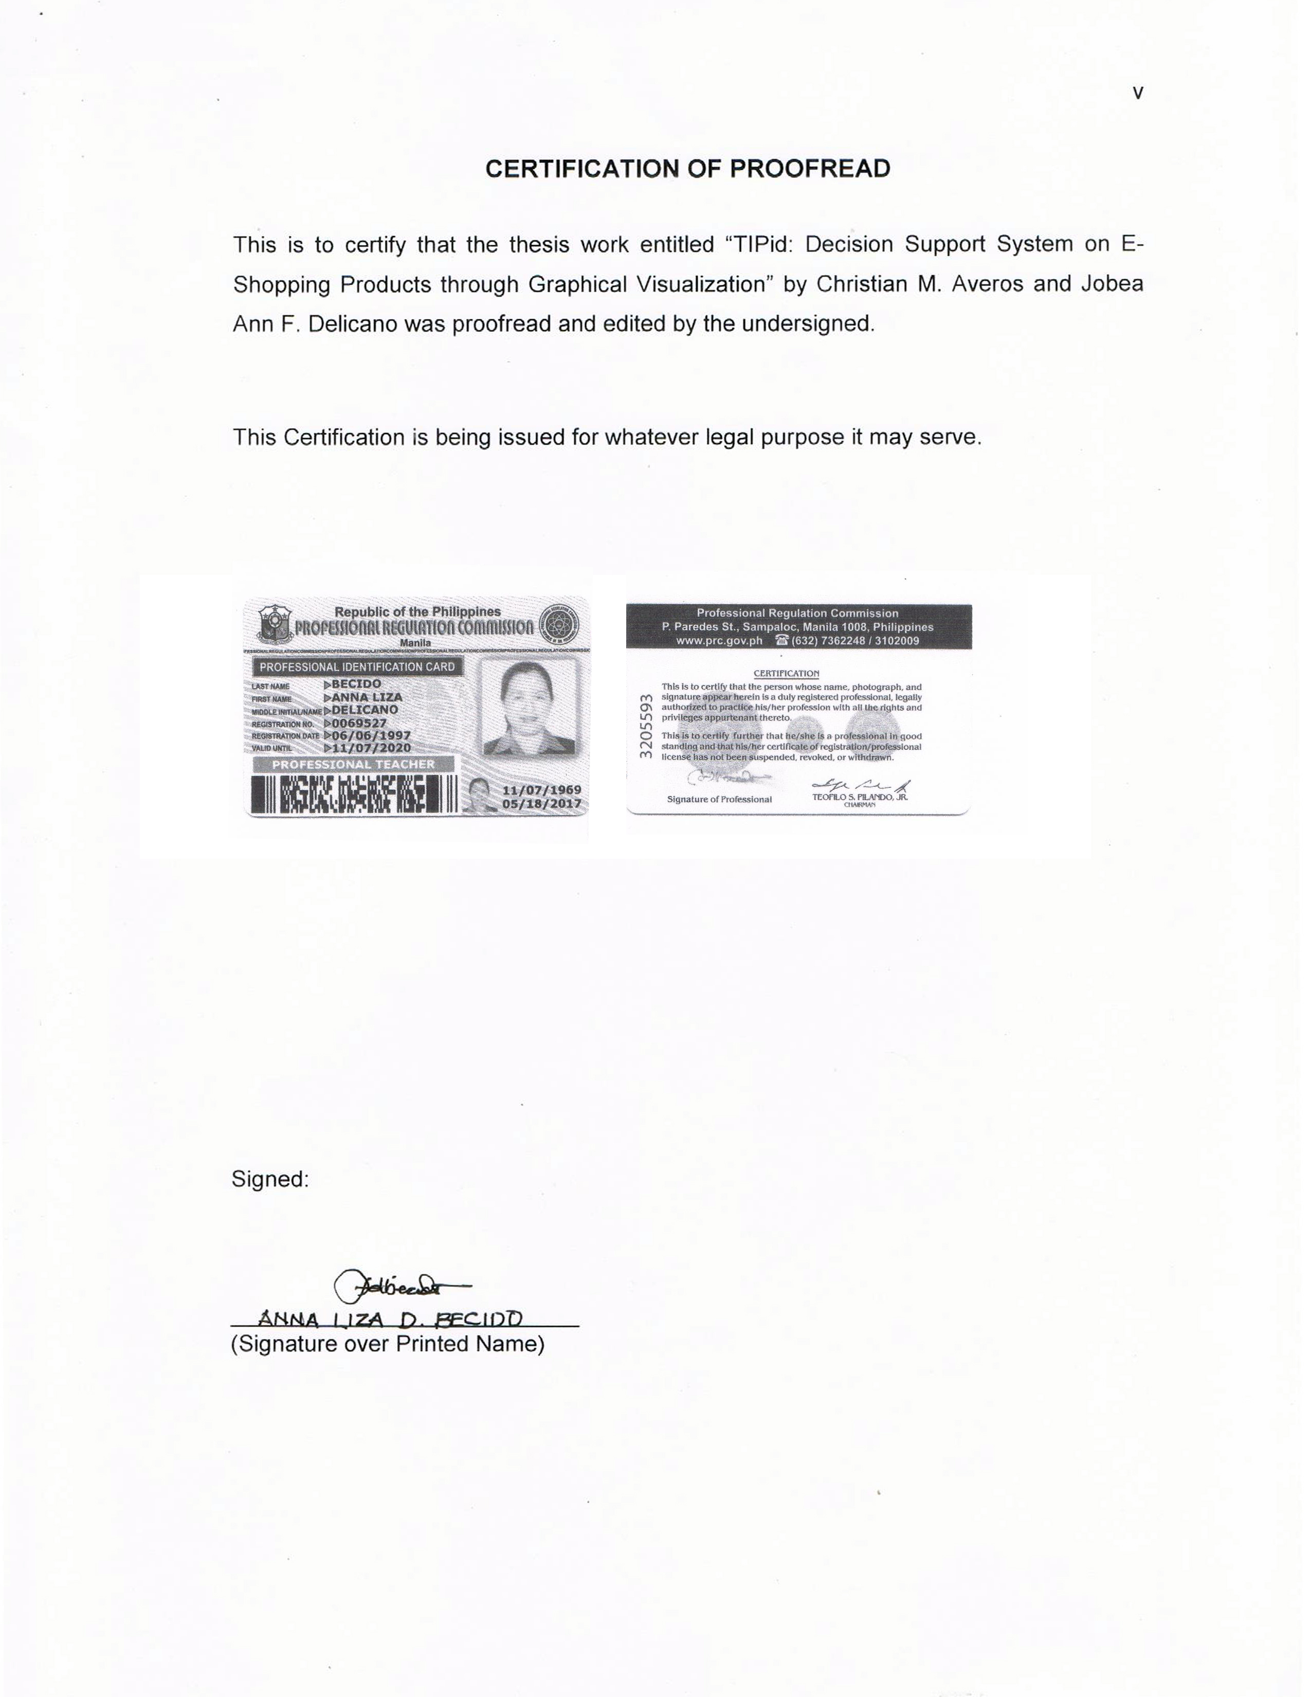

# SIGNATURE

The thesis “**TIPid: Decision Support System on E-Shopping Products through Graphical Visualization**” in partial fulfilment of the requirements for the degree of Bachelor of Science in Computer Science has been

Recommended for Approval and Acceptance: Date:

___________________________________ __________________  
Benilda Eleonor V. Comendador, DIT  
Faculty-In-charge

Approved by the Thesis Defense Panel:

___________________________________ __________________  
Benilda Eleonor V. Comendador, DIT

___________________________________ __________________  
Marian G. Arada, MIT

Accepted for the Department of Computer Science

___________________________________ __________________  
Melvin C. Roxas, MSGITS  
Department Chairperson

Accepted for the College of Computer and Information Sciences

___________________________________ __________________  
Gisela May A. Albano, PhD  
Dean of the College

# ABSTRACT

As new technologies arise, online food, apparel, and product delivery services came to spotlight. Along with the growth of online shopping websites comes with the growth of merchants offering different prices for the same product. When finding a befitting product to buy, users tend to buy cheaper similar products, however the process itself of searching for such cheaper alternatives can become tiresome as buyers would switch websites after websites and look for different sellers.

In order to lessen the time consumed searching for the optimal product for buyers with a fixed budget, the study aimed to develop a recommender system that searches and scrapes data on online shopping websites to provide lists of top 10 ranking products based on a combination of price and reviews, based on price, and based on reviews in a single page layout based on the user's search term input. The system used classification technique in data mining to identify the products a user wants to buy and Interleaved Ranking Algorithm list out the best products in the online market.

Through an experimental research method the system achieved 90.57% accuracy on acquiring relevant data, 72.80% on getting the best deals in terms of price ranking, and 58.40% in terms of reviews ranking. Therefore, having a 73.92% on the system's overall accuracy.

# ACKNOWLEDGEMENT

We, the researchers, wish to acknowledge and express gratitude to those who contributed to the success of this research work:

To our faculty adviser, who guided us and gave advices at the time of writing this thesis.

To the panel members, who pointed out flaws in our work and gave insightful comments in order to help enhance our work.

To our families, who financially and morally supported us during the time of working with this thesis.

To our internship mentors, who taught us the programming skills we applied on the development of the thesis tool.

And to ourselves, who gave our best on the writing of this thesis, development of the thesis tool, and supported each other in times of mental breakdowns.

Averos, Christian M.

Delicano, Jobea Ann F.

# TABLE OF CONTENTS

TIPID: DECISION SUPPORT SYSTEM ON E-SHOPPING PRODUCTS THROUGH GRAPHICAL VISUALIZATION i

AUTHORIZATION ii

AFFIDAVIT OF CO-OWNERSHIP iv

CERTIFICATION OF PROOFREAD v

SIGNATURE vi

ABSTRACT vii

ACKNOWLEDGEMENT viii

TABLE OF CONTENTS ix

LIST OF FIGURES xi

LIST OF TABLES xii

LIST OF NOTATION xiii

Chapter 1 THE PROBLEM AND ITS BACKGROUND 1

Background of the Study 2

Statement of the Problem 3

Theoretical/Conceptual Framework 4

Theoretical Framework 4

Conceptual framework 4

Significance of the Study 5

Scope and Limitation of the Study 5

Definition of Terms 5

Chapter 2 REVIEW OF LITERATURE AND STUDIES 6

Related Literature and Studies 6

Synthesis of the Study 12

CHAPTER 3 Research Methodology 11

Research Design 11

Sources of Data 11

Instrumentation 12

Software/Hardware Tools 12

System Architecture 12

Development Details 13

Research Instrument 13

Data Generation 14

Data Analysis 15

Chapter 4 RESULTS AND DISCUSSION 16

Chapter 5 SUMMARY, CONCLUSIONS AND RECOMMENDATIONS 24

Summary of the Findings 24

Conclusions 24

Recommendations 25

REFERENCES 27

APPENDICES 29

Appendix A: SAMPLE EXPERIMENT PAPER 29

Appendix B: IMPLEMENTATION REPORT 33

Appendix C: SCREENSHOTS OF THE SYSTEM 36

Appendix D: RESUME OF THE RESEARCHERS 38

# LIST OF FIGURES

Figure 1. System Theory Framework 4

Figure 2. System Architecture 12

Figure 3. Screenshot of TIPid Homepage 36

Figure 4. Top 10 Best Deals Section in Search Results Page 36

Figure 5. Top 10 Products based on Price Section 37

Figure 6. Top 10 Products based on Customer Reviews Section 37

# LIST OF TABLES

Table 1: Conceptual Framework of the System 4

Table 2: Performance of the developed system in using web crawler and spider with 0% to 75% accuracy 16

Table 3: Performance of the developed system in using web crawler and spider with 76% to 99% accuracy 17

Table 4: Performance of the developed system in using web crawler and spider with 100% accuracy 18

Table 5: Performance of the developed system in identifying the best deals in terms of price with 0% to 75% accuracy 19

Table 6: Performance of the developed system in identifying the best deals in terms of price with 76% to 100% accuracy 20

Table 7: Performance of the developed system in identifying the best deals in terms of customer reviews with 0% to 50% accuracy 21

Table 8: Performance of the developed system in identifying the best deals in terms of customer reviews with 60% to 100% accuracy 22

Table 9: Total accuracy of the system 23

Table 10: Sample experiment paper for getting the accuracy of the relevant items 29

Table 11: Sample experiment paper on getting the best deals based on price rankings and customer review rankings 30

Table 12: Sample experiment paper for total accuracy of the system 32

# LIST OF NOTATION

DM Data Mining

OSW Online Shopping Website

# Chapter 1 THE PROBLEM AND ITS BACKGROUND

In the fast-paced modern world, where technology progresses rampantly, we try to keep up with today's trends as well as needs. With the rise of technology, clinging unto technology makes our lives easier, and some experts say that the internet can now be consider a need along with food and shelter (Pastore, 1998). Everything is being digitalized as for our communication and work-processes, and with the use of the internet and its rapid development, delivery systems are getting more and more popular alongside of online shopping websites (OSWs). With that being said, it has great effect on Filipinos, especially modern Filipina who buy products on the internet through OSWs.

Most people all over the Philippines have access to the internet and they are still growing in numbers but there's a problem, how can we diminish the hard work process of searching through many OSWs just to get the best deals? The researchers are used to seeing their mothers go through many stores just to get the optimal price that fits in their budget, sometimes, they even come to a point of bargaining or asking the store to lower the price if we're going to buy bulk of their products. Similarly, E-Shoppers would search for many online shopping websites like Amazon and Lazada to compare and analyze what is the best for their searched similar products, weighing in the reviews, quantity, and even quality just to make sure that they're making a good decision upon purchasing such product. Searching and rummaging through many OSWs is a tiresome job. The proposed solution helps the user to remove the users the problem of doing such a tiresome work by going through the process itself providing the user a single comparison interface page. Providing 3 ranked lists each sorted by highest rating, by cheapest prices, and by the combination of the former two forming the best deals, respectively.

Alongside of many frameworks for building mobile and web applications, acquired data must be represented in a formal and understandable way for users to grasp in first glance the importance of this study. Visualizing dynamic data in a user-friendly interface can make users comprehend easily the content of the acquired unstructured data sets. Therefore, the researchers decided to develop a system to help with troubled online shoppers (OS).

## Background of the Study

Most Filipino shoppers have a hard time jumping to another store into other store just to find the best deals of their wanted product, may it be a new pair of shoes, shining jeans, or maybe a newly released branded cap. As much as we can, we bargain, bargain, and bargain. Most modern Filipino women would go to mall after mall just to buy off on-sale product which is also true for old-fashion mothers who would prefer to bargain just to get deals from their market suppliers. In today’s technological advantage, many shoppers prefer e-commerce as their mode of shopping (Kitonyi, 2017), primarily because internet is easy to access and buying is just a few clicks away.

Filipinos like to bargain, since the old times, Filipino mothers would go to the market with a fixed money and get much more worth of their money for. Just imagine the hard work of going through and bargaining to many stores just to lessen the pay for a similar product as well as avoiding similar low quality products. This is also true to online shoppers looking for looking for a specific product in an online store, they would search many online store just to get the best deal in their opinion. They would scan for reviews of the said product and sometimes to avoid getting scammed or getting less than what you expected. One of the most common problem in OSWs is that there are scammers always present (Bolido, 2014) even in the most trusted OSWs. As for saving, it is no wonder that getting the less payment is the best. Some men would pay double just to get the product they want as they deemed it worth it. Ratings and reviews comes into play as helpful elements in deciding on what to buy on the store.

Visualization is the representation of data in which is any technique for creating images, animations, and etc. to convey a message. Truly, life would be boring if there weren't many colors or shapes around. Both became one of the major tools in life for differentiating and comparing. In today's application of visualization, one of the tools it is used for, when it comes to websites and computer applications, is helping the users' on their experiences. It help them in the form of 'navigation', or even the colour and theme of the website to give more feeling of appropriate based on the contents.

With the visualization as the main part of knowing, and criticizing, and differentiating can be implemented in a decision-support system in which colours and shape helps in choosing one in the items in question. The researchers plan to build a system that caters in the selection of similar products in which the user has to decide to buy or not. Getting the data only from the trusted OSW to minimize cyber market scamming and increasing the satisfaction rate of the users in selecting. Filtering only the 'best' deals in terms of reviews, quantity, and popularity to get the most-likely product to be picked by the user.

## Statement of the Problem

This study aimed to develop a system that gets the best deal from various online shopping websites based on user’s search terms and apply a visualization technique to display the best deals. Specifically, this addressed the following sub-problems:

1. Using web crawler and scraper, what is the accuracy of the developed system in getting the relevant data from online shopping websites?
2. What is the performance of the developed system in utilizing Interleaved Ranking algorithm to identify the best deals in terms of:
   1. Price?
   2. Average Rating and Number of Customer Reviews?
3. What is the overall accuracy performance of the developed system?

## Theoretical/Conceptual Framework

### Theoretical Framework

Figure 1. System Theory Framework

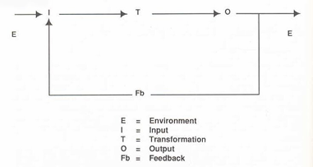

Figure 1 shows the theoretical framework of the system. System Theory is introduced by Ludwig von Bertalanffy. This theory points main four things that build up a system: objects, attributes, object-relationship and environment.

### Conceptual framework

Table 1 shows the conceptual framework of the system where the user’s search terms are the input data. The processes are getting the data from OSW and filtering out redundant data. The output data are the collection of best deals.

Table 1: Conceptual Framework of the System

|  |  |  |
| --- | --- | --- |
| **INPUT** | **PROCESS** | **OUTPUT** |
| User search term | Getting data from site  Filtering out redundant data  Analysis of the data set | Graphical Representation of the listed Best Deals |

## Significance of the Study

The system will benefit the following people:

**Online Shoppers**. This study would benefit shoppers who wants to lessen their time on selecting the best deal.

**Store Owners**. This will benefit them by being able to search how they would price their own products.

**Future Researchers**. This study will be a help as a guiding reference in making a system related to e-commerce.

## Scope and Limitation of the Study

This study focused on the accuracy of the finding the best deals of electronic products and accessories selected by the user at the top online shopping websites. The system mines data from popular retailer online shopping websites and does not include second hand online shopping websites, specifically:

1. Lazada (lazada.com.ph)

2. Shopee (shopee.ph)

3. Amazon (amazon.com)

The scope in assessing the best deals is based on the relevancy, availability, price excluding the shipping fee, and numerical reviews regarding the product. The product prices are displayed in Philippine Peso.

The system is not affiliated in selling products and only acts as a recommender system for finding the best deals.

## Definition of Terms

**Data Mining**. It is the process of extracting information from a large sets of data.

**Online shoppers**. Product consumers that uses Online Shopping Websites as their medium for purchasing.

**Online Shopping Websites**. Form of e-commerce that allows users to purchase commodities over the internet with the help of a web browser.

**Scammers**. People who extorts or uses dirty tactics to gain information, power or money.

# Chapter 2 REVIEW OF LITERATURE AND STUDIES

This chapter discusses papers related to the study including Data Mining: its techniques, tools and application; visualization techniques; and shopping: physical shopping and its problems, OSWs and its problem and application of data mining in OSWs.

## Related Literature and Studies

**Data Mining**

In the ever expanding data collection and data storage, Data Mining (DM) has been a logical process used to search useful information through piles of data. (Ramageri, 2010) Since data sets has become more complex and larger than it was, DM was improved by different algorithms discovered and developed in the field of computer science. DM is an important task in knowledge discovery in databases (KDD). (Li & Beaubouef, 2010) KDD consists procedures including (Smita & Sharma, 2014):

selection of data from varying sources;

preprocessing or data reduction;

transformation of data;

identifying the desired result; and

interpretation and analysis to give relevant information.

There are several DM techniques developed and applied in KDD (Bhatnagar et al., 2012):

Association. In association, a pattern is discovered based on a relationship of a particular item on other items in the same transaction. For example, the association technique is used in reservation systems analysis to identify in which area customers frequently make reservations.

Classification. Classification method makes use of mathematical techniques such as decision trees, linear programming, neural network and statistics. Basically classification is used to categorize each item in a set of data into one of predefined set of classes or groups.

Clustering. Clustering is a data mining technique that makes meaningful or useful cluster of objects that have similar characteristic using automatic technique. Different from classification, clustering technique also defines the classes and put objects in them, while in classification objects are assigned into predefined classes.

Prediction. It is one of a data mining techniques that discover relationship between independent variables and relationship between dependent and independent variables.

Sequential Patterns. Sequential patterns analysis is one of data mining technique that seeks to discover similar patterns in data transaction over a business period. The uncover patterns are used for further business analysis to recognize relationships among data.

Discrimination. Data discrimination produces what are called discriminant rules and is basically the comparison of the general features of objects between two classes referred to as the target class and the contrasting class.

DM is currently used in wide range of industries that holds a large amount of data and is commonly combining it in other tools that can enhance the power of DM in various fields. (Ramageri, 2010) Some of these fields include the field of biological science to analyze sequential pattern in genes and identify various diseases related to it. Finance industries use DM for price prediction, stock forecasting, identify frauds and money laundering. (Li & Beaubouef, 2010) Sales industry also use DM as in different ways (Al Essa & Bach, 2014):

Information broker for customer buying habits, from transaction histories to loyalty card usage. Because of this, supermarkets can predict customer behavior and act upon it for customer satisfaction and better sales;

Recommendation-based business that tracks customer's bought items and offer customer new items that they might also like;

Keeping good customers that boosts sales and avoiding fraudulent, bad customers;

Decision support system for both business holders and/or customers (Smita & Sharma, 2014); and

Other applications that can build customer relationship.

**Web Crawler**

Before acquiring data to be displayed, websites should be visited first. Web crawlers are used to automate website visits from time to time and partnered with a scraper in order to get needed data. Data mining techniques like classification is used in order to crawl to needed webpages to avoid wasting resources and to lessen noise from the data that will be obtained. (Mitra & Tan, 2010)

**Web Scraper**

Web scraper functions as a tool for obtaining the specific data needed from the website. Different data mining techniques are applied to get the data in a systematic way by grouping the data to discover hidden aspects of the data. Classification technique is used to scrape data given that there is a predefined class given as a basis (Dai et al., 2015).

**Data Analysis Techniques**

**Bayesian Estimation**

In order to avoid from bad product or service, consumers rely on product reviews by other consumers. Consumers automatically prejudge products on a five-star rating. This method is powerful and easy to understand but it can be mishandled when ranked since five-star ratings depends not only on the average number of stars but the average number of reviews. Take for example Product A with an average rating of 5 and a single review, and Product B with an average rating of 4 but has a hundred reviews. Not all cons Bayesian Estimation is an empirical metric that considers both average and number of reviews. This is done by using a probability distribution for each reviews given by a consumer on a specific product. By making a threshold parameter and taking a minimum number of ratings as a confidence for the threshold, a product is weighed according to the reviews it has received while still taking into consideration the true average of the product. Bayesian estimation is used in review sites such as IMDb.

**Interleaved Ranking Algorithm**

In product information retrieval where there are different factors to consider such as price and reviews, they, of course, are ranked differently depending how it is filtered. In order to make data retrieval efficient, the approach is to compare both rankings and display a single ranked list to the user. Both ranking are interpreted in an unbiased way and presented to the user to be more interpretable. One way of interleaving is by Team Draft wherein in adapts the analogy of selecting teams in a sports match. This way, both ranks are considered equally appending each item on the interleaved list in an alternate manner.

**Data Visualization**

Visualization provide users a comprehensive understanding about a data. It gives form to raw data making it coherent to the users. Using computer graphic effects, data sets can be visualized to display patterns, relationship and trends in a more advanced way. This gives users an ease to apprehend information by the use of visual reasoning rather than numerical reasoning. (Zhao, 2002) Presentation of data may involve the manipulation of graphical entities and attributes. A good data visualization must consider the effectiveness or ease of interpretation, accuracy or correct quantitative evaluation, efficiency or data redundancy removal, aesthetic or must be pleasant to the user's eye and adaptable or adjustable to serve multiple needs. According to Ward, common techniques on data visualization are following: charts, graphs, plots, maps, images, 3D surfaces and animation. Parsaye and Chignell listed the common steps followed in data visualization:

1) Numerical transformation of data by modifying the distribution

2) Data analysis to interpret data that will be used in graphical interpretation

3) Graphical interpretation by plotting the analyzed data onto graphs

4) User interaction by adding options for users to dynamically adjust mapping, zooming, panning, highlighting, et cetera.

**Shopping**

Shopping is the activity of trading goods and products for other goods and products. (Robertson, 2012) Simply put, exchanging a product for a more benefiting one, this can be; food, tools, money, ad etc. depending on your needs. In the early age of man, the art of exchanging goods took place in which leads to easier lives of the customers for they don't even have to hunt or gather food themselves in which fasten the growth of many communities. According to Oxford, markets or shopping malls have been the main place of trading, but they're often in urban areas or in the middle of the city which can be, depending where you live or just lazy, can be hard to go to. (Bund)

As technology develop and as our understanding of computers and the internet as well as the remaining difficulty of going to the market place, landlines, the internet and trading companies gave birth to ticket booking and food delivery services, and online shopping websites (OSWs). Pizzas, clothes, and pizza, can be delivered in front of your doorstep in a matter of minutes by the usage of the internet by visiting such OSWs. But be wary of scammers especially in the e-shopping category as they run rampant waiting for a user to be conned.

As the danger of scammers are not enough, one of the most commonly problem encountered by many users is the tedious work of manually comparing and searching of a particular type of product in many OSWs. Users have to go to multiple OSW just to type in the same keywords and is faced with many similar product in that OSW plus many more with the other OSWs. Reviewing the 'reviews', as well as looking in to the quantity, and the quality of the searched product come hand in hand which makes it hard for the comparison process thus making a decisive and long decision.

Fortunately, 'Comparison of ecommerce products using web mining authors', have started a way for tackling this issue way easier with the use of Data mining. Studying the HTML code structure of international OSWs such as Lazada and Amazon, and using web-crawling spider to scrape out unstructured data and organizing them to a meaningful data. They let the user input search terms that will display the comparing pair deals, successfully lessening the user's time for looking in different browser tabs. Displaying it in a single-view page for users to view and pick what they desire. However, displaying and adding a table of comparison for such products still doesn't solve the problem of finding the best deals an OSW can offer. Finding the best deals have to account the reviews of other users, quality, quantity, and availability of the product. (Mo, Z., Li, Y.-F. and Fan, P., 2015)

## Synthesis of the Study

There have been many studies that concerns in the field of data mining and visualization. One of the main researches that drives the researchers is the 'Comparison of E-commerce products in using web mining' research done in Savitribai Phule Pune University in where the users inputs two or more products to compare in a single page website. However, the main problem of Shah, et al.’s work is that the users are required to manually search and add the products for it to compare. Undisputedly, price is one of the considerations when people are trying to save money when buying a product. So is ratings and reviews as for considering the duration of use or the quality of the product. It’s true that people looked up to reviews to see if it’s worth it or not. In this study, the researchers attempt to gather data from the leading OSWs automatically responding the search terms or input of the users. The researchers limited to OSWs with branches in the Philippines to remove or reduce the cost of high delivery fee for products from foreign countries. Using the input of the user, the system then will collect products related to the input from the OSWs and finally, displayed according to their ranking. A total of 50 unique search terms are used for the regression test due to the shortage of electronic device categories with non-specific brand or merchant to provide fair competition to online merchants. As a decision support system, the system focuses on visualizing the products in a way that help convey the difference among the products as well as magnify the pros and cons.

For the gathering data relevant to the desired product of the user, the researchers used web scraper for acquiring the frequent relevant item sets. The prune data in will be stored in the a database to remove repeating data or noise data then subjected to an algorithm called Interleaved ranking algorithm with Bayesian estimation to find the best deals to be visualize in a single view page. For the visualization, the users can view graphs and statistics which can help in deciding on what to buy.

# CHAPTER 3 Research Methodology

This chapter defines the research methods used to conduct the study. It involves the research method that will be used, paradigm, system architecture and the data gathering procedure.

## Research Design

The research design of this study used the Experimental research design. The aim of the experiment is to determine if the system is a reliable and accurate approach in the delivery of gathered best deals in the selected OSWs. With the use of this design, the researchers have reached and come up with the answers to the questions stated in the statement of the problem.

In determining the overall performance of the system in gathering the best deals, the researchers lead an experiment. The respondents, described in the Research instrument in Instrumentation, compare the system's actual output and the expected result by the researchers to measure the system's performance in accuracy, reliability, and consistency in getting the best deals.

## Sources of Data

The respondents were both the researchers and searching online shoppers. The respondents used search terms to train the system and is given a set of possible best deals. The respondents then evaluated the accuracy and reliability of the system.

## Instrumentation

## Software/Hardware Tools

### System Architecture

Figure 2. System Architecture

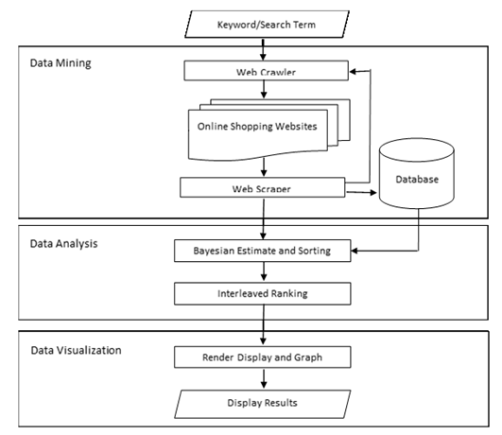

**Data Mining**. The product keyword will be used in order to get the specific items from OSWs. Using the Web Crawler to go to each OSWs, the Web Scraper will then mine relevant data and stored them in database.

**Data Analysis**. After the Web Scraper is done storing the relevant items in the database, the items will be duplicated in an exact duplicate set of two namely set A and set B After computing the Bayesian estimate according to the ratings and reviews. Set A will be sorted starting with the lowest price and set B will be sorted according to the Bayesian estimate of the reviews. The two sets will undergo through interleaved ranking to get the ranked set.

**Data Visualization**. After acquiring the ranked set through interleaving, top 10 items will be displayed as the Best Deals item set. The top 10 in Set A and Set B, which were ranked by price and reviews will be displayed and called as the ‘candidate’ set. The scatter plot figure of Matplot library will be used to plot and display the item values onto a graph that will compare and show the difference between the ranked products.

### Development Details

The researcher's will use the following tools in order to develop the system:

**Python**. A multi-paradigm programming language with high-level data structures and highly readable syntax that can be used on most platforms. This language will be used to create the backend for the system.

**Django Framework**. A server-side web framework written in Python which will be used to create the user-interface for the system.

**BeautifulSoup**. A web crawling framework written in Python. This will be used to crawl and extract data from various data sources.

**Selenium Webdriver**. Webdriver that will be used to run the web crawlers on browser.

## Research Instrument

Experiment paper will be used to measure and record results while testing the system.

## Data Generation

The following are the procedures in gathering data used by the researchers for the study:

**Software Related Data**

Maximum of (20) product data sets per OSW each for a maximum of sixty (60) products data sets were gathered will be stored in a database. The data acquired from the three (3) OSWs are then further reduced and extracted only the best out of all the data. The data sets of ten (10) 'Best deals' are sorted according to the respondent's preference and finally displayed.

**Survey & Testing Data**

A regression test of fifty (50) unique search terms related to electronic devices were used as testing data sets. The search terms were used in order to extract item set from OSWs. Accuracy of the relevant data in extracted item set were evaluated by tallying the number of items related to the search term given. The extracted item set was ranked by price and another similar extracted item set will be ranked by reviews. The top 10 in both ranked sets were classified as the candidate items for the best deals. The two ranked item sets underwent interleaved ranking and the top 10 were the best deals. The accuracy was acquired by counting the candidate items present in the best deals and using the recall formula. The total accuracy of the system was computed by getting the average of the accuracy of the relevant items, accuracy of best deal by price and accuracy of by reviews.

## Data Analysis

In order to solve for the first problem, accuracy of the scraped set by the Web Scraper was computed by the following formula:

where: = accuracy

= number of relevant item in set

= total number of item in set

The formula of Bayesian Estimation in the second problem was used for evaluation of the ranking in the 'scraped' data sets:

where: = Bayesian estimate

. = mean over the ratings for the items.

= confidence

= number of reviews

= threshold parameter

The formula of Recall was used on solving second problem to get the accuracy:

where: *𝑥* = Accuracy

*𝑐𝑏* = no. of candidate (price/review) - best deal item

*𝑛𝑏* = no. of non-candidate (price/review) – best deal item

To solve the third problem, mean formula was used:

where: *𝑥* = total accuracy of the system

# Chapter 4 RESULTS AND DISCUSSION

The purpose of the study is to provide recommendable best product deals from the Internet based on its price and reviews according to the user’s search term input. The analysis of the test results gives an idea on the accuracy of the system can show list of the products that will give the user an idea on what product is the best to buy. Fifty (50) technology-related search terms were used to test the system and answer the problem stated in the first chapter.

The discussion below is presented to answer the following question/s:

1. Using web crawler and scraper, what is the accuracy of the developed system in getting the relevant data from online shopping websites?

Table : Performance of the developed system in using web crawler and spider with 0% to 75% accuracy

|  |  |  |  |  |
| --- | --- | --- | --- | --- |
| # | Search Terms | Number of Relevant Items | Total Number Of Items | Accuracy of getting relevant items |
|
|
| 1 | Usb Steering Wheel | 7 | 40 | 17.50% |
| 2 | 4gb RAM | 19 | 40 | 47.50% |
| 3 | Videocard | 23 | 40 | 57.50% |
| 4 | Cooling Pads | 29 | 43 | 67.44% |
| 5 | Laser Printer | 28 | 40 | 70.00% |
| 6 | Wireless Keyboard | 43 | 59 | 72.88% |

Table 2 shows the accuracy of each search terms ranging from 0% to 75%. USB steering wheel got the lowest accuracy of 17.5%. Most of the products showed were not directly related to USB steering wheels for gaming, but a music player with a USB port attachable to the steering wheel. 4GB RAM got second lowest accuracy since majority of the products showed were smartphone units with 4GB RAM specifications. Four (4) items got an accuracy ranging from 50% to 70%.

Table 3: Performance of the developed system in using web crawler and spider with 76% to 99% accuracy

|  |  |  |  |  |
| --- | --- | --- | --- | --- |
| # |  | # of Relevant Items | Total Number Of Items | Accuracy of getting relevant items |
|
|
| 7 | Polaroid Camera | 45 | 58 | 77.59% |
| 8 | 4g Pocket Wifi | 36 | 45 | 80.00% |
| 9 | Projector | 49 | 60 | 81.67% |
| 10 | Surround Sound Microphone | 33 | 40 | 82.50% |
| 11 | Breadboard | 35 | 41 | 85.37% |
| 12 | Digital Camera | 45 | 52 | 86.54% |
| 13 | Wireless Controller | 46 | 52 | 88.46% |
| 14 | Washing Machine | 40 | 45 | 88.89% |
| 15 | Ps3 Controller | 36 | 40 | 90.00% |
| 16 | Android Charger | 37 | 40 | 92.50% |
| 17 | Midi Keyboard | 37 | 40 | 92.50% |
| 18 | Motherboard | 37 | 40 | 92.50% |
| 19 | Gaming Mouse | 56 | 60 | 93.33% |
| 20 | Battery Charger | 56 | 60 | 93.33% |
| 21 | Hdmi Adapter | 55 | 58 | 94.83% |
| 22 | Wireless Microphone | 44 | 46 | 95.65% |
| 23 | 1tb External Hard Drive | 58 | 60 | 96.67% |
| 24 | 4k Tv | 35 | 36 | 97.22% |
| 25 | Drawing Tablet | 40 | 41 | 97.56% |
| 26 | Dvd Player | 42 | 43 | 97.67% |
| 27 | Led Monitor | 43 | 44 | 97.73% |
| 28 | Bluetooth Speaker | 59 | 60 | 98.33% |
| 29 | Gaming Keyboard | 59 | 60 | 98.33% |
| 30 | Wireless Mouse | 59 | 60 | 98.33% |
| 31 | Web Cam | 59 | 60 | 98.33% |

Table 3 shows twenty-five (25) search terms with accuracy ranging from 76% to 99%.

Table 4: Performance of the developed system in using web crawler and spider with 100% accuracy

|  |  |  |  |  |
| --- | --- | --- | --- | --- |
| # | Search Terms | # of Relevant Items | Total Number Of Items | Accuracy of getting relevant items |
|
|
| 32 | Led Keyboard | 42 | 42 | 100.00% |
| 33 | Led Mouse | 42 | 42 | 100.00% |
| 34 | Silent Mouse | 53 | 53 | 100.00% |
| 35 | Bluetooth Earphone | 60 | 60 | 100.00% |
| 36 | Gaming Headset | 57 | 57 | 100.00% |
| 37 | Silent Keyboard | 40 | 40 | 100.00% |
| 38 | 10000mah Power Bank | 60 | 60 | 100.00% |
| 39 | Iphone 7 Case | 48 | 48 | 100.00% |
| 40 | Vga Adapter | 56 | 56 | 100.00% |
| 41 | Usb 3.0 Cable | 52 | 52 | 100.00% |
| 42 | Avr (Automatic Voltage Regulator) | 41 | 41 | 100.00% |
| 43 | 32gb Flash Drive | 60 | 60 | 100.00% |
| 44 | Dash Cam | 60 | 60 | 100.00% |
| 45 | 32gb Memory Card | 60 | 60 | 100.00% |
| 46 | Pointer Clicker | 40 | 40 | 100.00% |
| 47 | Vr Headset | 40 | 40 | 100.00% |
| 48 | Router | 60 | 60 | 100.00% |
| 49 | Scientific Calculator | 48 | 48 | 100.00% |
| 50 | Drone | 40 | 40 | 100.00% |
|  |  |  | **TOTAL**: 90.57% | | |

Table 4 shows search terms that got a perfect accuracy and the total accuracy of the System in getting the relevant items. Nineteen (19) search terms got a 100% accuracy. The search terms which got a high accuracy displayed product which were directly related to the user’s expectations. The total accuracy of the system in getting the relevant items is 90.57%.

1. What is the performance of the developed system in utilizing Interleaved Ranking algorithm to identify the best deals in terms of:
   1. Price?
   2. Average Rating and Number of Customer Reviews?

Table : Performance of the developed system in identifying the best deals in terms of price with 0% to 75% accuracy

|  |  |  |  |  |
| --- | --- | --- | --- | --- |
| # | Search Terms | Number of Candidate Products in Best Deals list based on price rankings | Number of Non-Candidate products in Best Deals list based on price rankings | Accuracy of getting the best deals based on price rankings |
| 1 | USB Steering Wheel | 2 | 8 | 20% |
| 2 | 4g Pocket Wifi | 5 | 5 | 50% |
| 3 | Digital Camera | 6 | 4 | 60% |
| 4 | Midi Keyboard | 6 | 4 | 60% |
| 5 | Hdmi Adapter | 6 | 4 | 60% |
| 6 | Cooling Pads | 6 | 4 | 60% |
| 7 | Polaroid Camera | 6 | 4 | 60% |
| 8 | Dash Cam | 6 | 4 | 60% |
| 9 | Laser Printer | 6 | 4 | 60% |
| 10 | Wireless Microphone | 6 | 4 | 60% |
| 11 | Projector | 6 | 4 | 60% |
| 12 | Dvd Player | 6 | 4 | 60% |
| 13 | Router | 6 | 4 | 60% |
| 14 | Scientific Calculator | 6 | 4 | 60% |
| 15 | Battery Charger | 6 | 4 | 60% |
| 16 | Drawing Tablet | 7 | 3 | 70% |
| 17 | Led Keyboard | 7 | 3 | 70% |
| 18 | Silent Mouse | 7 | 3 | 70% |
| 19 | Gaming Headset | 7 | 3 | 70% |
| 20 | Ps3 Controller | 7 | 3 | 70% |
| 21 | Wireless Keyboard | 7 | 3 | 70% |
| 22 | Iphone 7 Case | 7 | 3 | 70% |
| 23 | Usb 3.0 Cable | 7 | 3 | 70% |
| 24 | Web Cam | 7 | 3 | 70% |
| 25 | Breadboard | 7 | 3 | 70% |
| 26 | Washing Machine | 7 | 3 | 70% |
| 27 | Drone | 7 | 3 | 70% |
| 28 | 4gb RAM | 7 | 3 | 70% |
| 29 | Videocard | 7 | 3 | 70% |

Table 5 shows accuracy in getting the ranked best deals based on price rankings ranging 50% to 75%. USB steering wheel gets the lowest accuracy of 20%. One (1) item—4G Pocket Wifi—gets an accuracy of 50%. Twenty-seven (27) search terms got an accuracy ranging 60% to 70%. USB Steering Wheel, which got the lowest accuracy, showed products with low prices yet low customer reviews.

Table : Performance of the developed system in identifying the best deals in terms of price with 76% to 100% accuracy

|  |  |  |  |  |
| --- | --- | --- | --- | --- |
| # | Search Terms | # of Candidate Products in Best Deals list based on price rankings | # of Non-Candidate products in Best Deals list based on price rankings | Accuracy of getting the best deals based on price rankings |
| 30 | Bluetooth Speaker | 8 | 2 | 80% |
| 31 | Gaming Keyboard | 8 | 2 | 80% |
| 32 | Led Mouse | 8 | 2 | 80% |
| 33 | Bluetooth Earphone | 8 | 2 | 80% |
| 34 | Wireless Controller | 8 | 2 | 80% |
| 35 | Silent Keyboard | 8 | 2 | 80% |
| 36 | Wireless Mouse | 8 | 2 | 80% |
| 37 | 1tb External Hard Drive | 8 | 2 | 80% |
| 38 | Avr (Automatic Voltage Regulator) | 8 | 2 | 80% |
| 39 | 32gb Flash Drive | 8 | 2 | 80% |
| 40 | 4k Tv | 8 | 2 | 80% |
| 41 | 32gb Memory Card | 8 | 2 | 80% |
| 42 | Pointer Clicker | 8 | 2 | 80% |
| 43 | Surround Sound Microphone | 8 | 2 | 80% |
| 44 | Vr Headset | 8 | 2 | 80% |
| 45 | Motherboard | 8 | 2 | 80% |
| 46 | 10000mah Power Bank | 9 | 1 | 90% |
| 47 | Vga Adapter | 9 | 1 | 90% |
| 48 | Led Monitor | 9 | 1 | 90% |
| 49 | Gaming Mouse | 10 | 0 | 100% |
| 50 | Android Charger | 10 | 0 | 100% |
|  |  |  | **TOTAL:**72.8% | |

Table 6 shows the list of search terms with accuracy ranging from 80% to 100% and the total accuracy of getting the ranked best deals based on the price rankings. Twenty (19) search terms got an accuracy ranging from 80% to 90%. Two (2) products—gaming mouse and android charger—gets the perfect accuracy. These two search terms displayed products with low prices and high customer reviews. The total accuracy of getting ranked best deals based on price rankings is 72.8%.

Table 7: Performance of the developed system in identifying the best deals in terms of customer reviews with 0% to 50% accuracy

|  |  |  |  |  |
| --- | --- | --- | --- | --- |
| # | Search Terms | # of Candidate Products in Best Deals list based on customer review rankings | # of Non-Candidate products in Best Deals list based on customer review rankings | Accuracy of getting the best deals based on customer review rankings |
| 1 | Drawing Tablet | 3 | 7 | 30% |
| 2 | 4g Pocket Wifi | 4 | 6 | 40% |
| 3 | USB 3.0 Cable | 4 | 6 | 40% |
| 4 | Web Cam | 4 | 6 | 40% |
| 5 | Breadboard | 4 | 6 | 40% |
| 6 | Gaming Keyboard | 4 | 6 | 40% |
| 7 | 32gb Memory Card | 4 | 6 | 40% |
| 8 | Led Monitor | 4 | 6 | 40% |
| 9 | Laser Printer | 5 | 5 | 50% |
| 10 | Projector | 5 | 5 | 50% |
| 11 | Battery Charger | 5 | 5 | 50% |
| 12 | Led Keyboard | 5 | 5 | 50% |
| 13 | Silent Mouse | 5 | 5 | 50% |
| 14 | Gaming Headset | 5 | 5 | 50% |
| 15 | Ps3 Controller | 5 | 5 | 50% |
| 16 | Iphone 7 Case | 5 | 5 | 50% |
| 17 | 4gb RAM | 5 | 5 | 50% |
| 18 | Silent Keyboard | 5 | 5 | 50% |
| 19 | Pointer Clicker | 5 | 5 | 50% |
| 20 | Surround Sound Microphone | 5 | 5 | 50% |
| 21 | Usb Steering Wheel | 5 | 5 | 50% |
| 22 | Vga Adapter | 5 | 5 | 50% |

Table 7 shows accuracy in getting the ranked best deals based on customer review rankings ranging 30% to 50%. Drawing tablet gets the lowest accuracy of 30%. The products displayed had high customer reviews yet high prices. Twenty-one (21) search terms got an accuracy ranging 40% to 50%.

Table 8: Performance of the developed system in identifying the best deals in terms of customer reviews with 60% to 100% accuracy

|  |  |  |  |  |
| --- | --- | --- | --- | --- |
| # | Search Terms | # of Candidate Products in Best Deals list based on customer review rankings | # of Non-Candidate products in Best Deals list based on customer review rankings | Accuracy of getting the best deals based on customer review rankings |
| 23 | Hdmi Adapter | 6 | 4 | 60% |
| 24 | Cooling Pads | 6 | 4 | 60% |
| 25 | Polaroid Camera | 6 | 4 | 60% |
| 26 | Dash Cam | 6 | 4 | 60% |
| 27 | Wireless Microphone | 6 | 4 | 60% |
| 28 | Dvd Player | 6 | 4 | 60% |
| 29 | Led Mouse | 6 | 4 | 60% |
| 30 | Bluetooth Earphone | 6 | 4 | 60% |
| 31 | Wireless Controller | 6 | 4 | 60% |
| 32 | Wireless Mouse | 6 | 4 | 60% |
| 33 | 1tb External Hard Drive | 6 | 4 | 60% |
| 34 | Avr (Automatic Voltage Regulator) | 6 | 4 | 60% |
| 35 | Vr Headset | 6 | 4 | 60% |
| 36 | Gaming Mouse | 6 | 4 | 60% |
| 37 | Digital Camera | 7 | 3 | 70% |
| 38 | Midi Keyboard | 7 | 3 | 70% |
| 39 | Wireless Keyboard | 7 | 3 | 70% |
| 40 | Washing Machine | 7 | 3 | 70% |
| 41 | Drone | 7 | 3 | 70% |
| 42 | Bluetooth Speaker | 7 | 3 | 70% |
| 43 | 32gb Flash Drive | 7 | 3 | 70% |
| 44 | 4k Tv | 7 | 3 | 70% |
| 45 | Motherboard | 10 | 3 | 70% |
| 46 | Router | 8 | 2 | 80% |
| 47 | Scientific Calculator | 8 | 2 | 80% |
| 48 | 10000mah Power Bank | 8 | 2 | 80% |
| 49 | Videocard | 10 | 0 | 100% |
| 50 | Android Charger | 10 | 0 | 100% |
|  |  |  | TOTAL: | 58.4% |

Table 8 shows the accuracy of getting the ranked best deals based on the average rating and number of costumer reviews ranging from 60% to 100% and the total accuracy of getting the ranked best deals based on the average rating and number of customer reviews. Twenty-three (23) search term got an accuracy ranging from 60% to 70%. Three (3) search terms got an accuracy of 80%. Two (2) search terms—videocard and android charger—got a perfect accuracy. The search terms which got a high accuracy displayed products with high customer reviews and low prices. The total accuracy of getting the ranked best deals based on the average rating and number of costumer reviews is 58.4%.

1. What is the overall accuracy performance of the developed system?

Table : Total accuracy of the system

|  |  |  |  |
| --- | --- | --- | --- |
| Accuracy of getting relevant items | Accuracy of getting the best deals in terms of: | | Overall Accuracy |
|
|
|  | Price | Customer Reviews |  |
| 90.57% | 72.80% | 58.40% | 73.92% |

Based on the Table 9, by getting the average of total accuracy of getting relevant items, total accuracy of getting the best deals based on price, and total accuracy of getting the best deals based on reviews, we can get the overall accuracy of the system. A total of 73.82% accuracy was achieved by the System.

# Chapter 5 SUMMARY, CONCLUSIONS AND RECOMMENDATIONS

This chapter presents the summary, conclusion, and the recommendations of the study. It is also discussed the findings and results made from the information gathered in experimenting the accuracy of the System in giving the best deals.

## Summary of the Findings

The study aimed to develop a system that provide recommendable best deal products among the online shopping websites. The research method in this study is through experimental design.

The first problem stated in Chapter 1 asked the accuracy of getting the relevant items using the mean formula. The results shows that the accuracy for getting the relevant items is 90.57%.

The second problem statement asked for the accuracy of getting the best deals in terms of price and reviews. The results found that the accuracy of getting the best deals according to price and review ranking is 72.80% and 58.40%, respectively.

The third problem statement asked for the overall accuracy of the System in providing relevant best deals items according to price and review ranking. The System receives 73.92%

## Conclusions

Through the testing and analysis of the results, the researchers have concluded the following:

1. The researchers found that accuracy of getting the relevant data in online shopping websites heavily weighs on the ambiguity of the search term. “4GB ram” search term test got the lowest accuracy of getting the relevant data since the term can be used to specify a desktop computer hardware or a specifications of a smartphone unit. VR Headset got a 100% accuracy of getting the relevant data due to lack of ambiguity. Therefore, the lower the ambiguity of the search term, higher the accuracy of getting the relevant data.
2. The total accuracy of getting the best deals in terms of price is higher than in terms of reviews due to the products in the price ranking having a good review rates and review rankings having listing highly reviewed yet expensive products. The highly reviewed expensive products will rank low in the price rankings and the products with good reviews which ranked high in the price rankings will be ranked on a middle rather than low. During the merging of two rankings, the products which topped the price ranking would get ranked high in the best deals rank. The researchers therefore concluded that most products with low price and good reviews are more likely to be included in top 10 best deals rather than highly reviewed yet expensive products.
3. The overall accuracy of the System is moderately high. The researchers found that there are factors which affects the overall accuracy of the System. The factors that affects the accuracy of the system is the ambiguity of the search term, and the price and review of the products.

## Recommendations

The researchers suggest the following improvements to the system to further enhance the results which answers the statement of the problem.

1. To get higher accuracy on getting relevant data, it is advised to use filtering options to get a more specific and relevant output.
2. To get higher accuracy on best deals based on customer review rankings, other methods and algorithms to merge price rankings and customer review rankings should be considered.
3. In order to achieve higher results on the overall accuracy of the system, application of filtering options and improvement of algorithm to merge price rankings and customer review rankings.

Other recommendations for the overall performance and improvement of the system includes the following:

1. Add more online shopping websites for wider selection of products.
2. Use a different data mining approach to improve speed of data extraction from online shopping websites.
3. Improvement of the User Interface and User Experience of the system.
4. Testing the system on different time intervals to check the differences and variations of results’ effectiveness on the accuracy of time.

# REFERENCES

Al Essa, Bach, C. (2014, April). *Data Mining and Warehousing*.

Bhatnagar, Jadye, Nagar. (2012, November). *Data Mining Techniques & Distinct Applications: A Literature Review.*

Bolido, L (2014, April 23). Safety in Online Buying and Selling. Retrieved from http://lifestyle.inquirer.net/157606/safety-in-online-buying-and-selling/

Bund: friends of the earth, Germany. (Accessed 12 August 2017) Shopping by bike. Retrieved from http://www.einkaufen-mit-dem-rad.de/shopping_by_bike.shtml

Dai, K., Nespereira, C., Vilas, A., & Redondo, R. (2015). Scraping and Clustering Techniques for the Characterization of LinkedIn Profiles.

Dr. Sudha, T. & Vasavi, G. (2017, March). Information Extraction from Online Shopping Sites using Web Content Mining Methods and Techniques.

Javadi, Dolatabadi, Nourbakhsh, Poursaeedi, & Asadollahi (2012, June). An Analysis of Factors Affecting on Online Shopping Behaviour of Consumers.

Kaidi, Z. (2002). Data visualization.

Kitonyi, N. (2017, March 07). E-commerce is Killing Traditional Retail. Retrieved from https://www.gurufocus.com/news/490164/ecommerce-is-killing-traditional-retail

Li, Y. & Beaubouef, T. (2010). Data Mining: Concepts, Background and Methods of Integrating Uncertainty in Data Mining.

Mitra, P. & Tan, Q. (2010). Clustering-based Incremental Web Crawling

Mo, Z., Li, Y.F. & Fan, P. (2015) Effect of Online Reviews on Consumer Purchase Behavior. Journal of Service Science and Management, 8, 419-424. http://dx.doi.org/10.4236/jssm.2015.83043

Nazir, Tayyab, Sajid, Rashid, & Javed. (2012, May). How Online Shopping Is Affecting Consumers Buying Behavior in Pakistan?

Oxford: Oxford University Press. (Accessed 12 August 2017) Retrieved from https://en.oxforddictionaries.com/definition/market

Parsaye K. & Chignell M. Intelligent Database Tools & Applications.

Pastore, M. (1998, December 03). Internet Becoming Necessity to Users. Retrieved from https://www.clickz.com/internet-becoming-necessity-to-users/72138/

Ramageri, B. M. (2010, December). Data Mining Techniques and Applications.

Robertson, P. (2012, November). Robertson’s Book of Firsts: Who did what for the first time?

Smita & Sharma P. (2014, June). Use of Data Mining in Various Field: A Survey Paper.

Ward, M. Overview of Data Visualization. Retrieved from www.cs.wpi.edu

# APPENDICES

## Appendix A: SAMPLE EXPERIMENT PAPER

Table : Sample experiment paper for getting the accuracy of the relevant items

|  |  |  |  |  |
| --- | --- | --- | --- | --- |
| **#** | **Search Terms** | **# of Relevant Items** | **Total Number Of Items** | **Accuracy of getting relevant items** |
|
|
| 1 | Drawing Tablet |  |  |  |
| 2 | Bluetooth Speaker |  |  |  |
| 3 | Gaming Mouse |  |  |  |
| 4 | Led Keyboard |  |  |  |
| 5 | Gaming Keyboard |  |  |  |
| 6 | Led Mouse |  |  |  |
| 7 | Silent Mouse |  |  |  |
| 8 | Bluetooth Earphone |  |  |  |
| 9 | Gaming Headset |  |  |  |
| 10 | Digital Camera |  |  |  |
| 11 | Wireless Controller |  |  |  |
| 12 | Ps3 Controller |  |  |  |
| 13 | Silent Keyboard |  |  |  |
| 14 | Wireless Keyboard |  |  |  |
| 15 | Wireless Mouse |  |  |  |
| 16 | Android Charger |  |  |  |
| 17 | 10000mah Power Bank |  |  |  |
| 18 | Midi Keyboard |  |  |  |
| 19 | Iphone 7 Case |  |  |  |
| 20 | 1tb External Hard Drive |  |  |  |
| 21 | Hdmi Adapter |  |  |  |
| 22 | Vga Adapter |  |  |  |
| 23 | Usb 3.0 Cable |  |  |  |
| 24 | Cooling Pads |  |  |  |
| 25 | Avr (Automatic Voltage Regulator) |  |  |  |
| 26 | 32gb Flash Drive |  |  |  |
| 27 | Led Monitor |  |  |  |
| 28 | 4k Tv |  |  |  |
| 29 | Polaroid Camera |  |  |  |
| 30 | Dash Cam |  |  |  |
| 31 | Laser Printer |  |  |  |
| 32 | 32gb Memory Card |  |  |  |
| 33 | Wireless Microphone |  |  |  |
| 34 | Web Cam |  |  |  |
| 35 | Projector |  |  |  |
| 36 | Pointer Clicker |  |  |  |
| 37 | Dvd Player |  |  |  |
| 38 | Surround Sound Microphone |  |  |  |
| 39 | Vr Headset |  |  |  |
| 40 | 4g Pocket Wifi |  |  |  |
| 41 | Router |  |  |  |
| 42 | Scientific Calculator |  |  |  |
| 43 | Breadboard |  |  |  |
| 44 | Washing Machine |  |  |  |
| 45 | Usb Steering Wheel |  |  |  |
| 46 | Drone |  |  |  |
| 47 | Battery Charger |  |  |  |
| 48 | 4gb RAM |  |  |  |
| 49 | Motherboard |  |  |  |
| 50 | Videocard |  |  |  |
|  |  |  |  | **Total:** |

Table 11: Sample experiment paper on getting the best deals based on price rankings and customer review rankings

|  |  |  |  |  |  |  |  |
| --- | --- | --- | --- | --- | --- | --- | --- |
| **#** | **Search Terms** | **# of Candidate Products in Best Deals list** | | **# of Non-Candidate products in Best Deals list** | | **Accuracy of getting the best deals based on:** | |
|
|
|  |  | **Price** | **Reviews** | **Price** | **Reviews** | **Price** | **Reviews** |
| 1 | Drawing Tablet |  |  |  |  |  |  |
| 2 | Bluetooth Speaker |  |  |  |  |  |  |
| 3 | Gaming Mouse |  |  |  |  |  |  |
| 4 | Led Keyboard |  |  |  |  |  |  |
| 5 | Gaming Keyboard |  |  |  |  |  |  |
| 6 | Led Mouse |  |  |  |  |  |  |
| 7 | Silent Mouse |  |  |  |  |  |  |
| 8 | Bluetooth Earphone |  |  |  |  |  |  |
| 9 | Gaming Headset |  |  |  |  |  |  |
| 10 | Digital Camera |  |  |  |  |  |  |
| 11 | Wireless Controller |  |  |  |  |  |  |
| 12 | Ps3 Controller |  |  |  |  |  |  |
| 13 | Silent Keyboard |  |  |  |  |  |  |
| 14 | Wireless Keyboard |  |  |  |  |  |  |
| 15 | Wireless Mouse |  |  |  |  |  |  |
| 16 | Android Charger |  |  |  |  |  |  |
| 17 | 10000mah Power Bank |  |  |  |  |  |  |
| 18 | Midi Keyboard |  |  |  |  |  |  |
| 19 | Iphone 7 Case |  |  |  |  |  |  |
| 20 | 1tb External Hard Drive |  |  |  |  |  |  |
| 21 | Hdmi Adapter |  |  |  |  |  |  |
| 22 | Vga Adapter |  |  |  |  |  |  |
| 23 | Usb 3.0 Cable |  |  |  |  |  |  |
| 24 | Cooling Pads |  |  |  |  |  |  |
| 25 | Avr (Automatic Voltage Regulator) |  |  |  |  |  |  |
| 26 | 32gb Flash Drive |  |  |  |  |  |  |
| 27 | Led Monitor |  |  |  |  |  |  |
| 28 | 4k Tv |  |  |  |  |  |  |
| 29 | Polaroid Camera |  |  |  |  |  |  |
| 30 | Dash Cam |  |  |  |  |  |  |
| 31 | Laser Printer |  |  |  |  |  |  |
| 32 | 32gb Memory Card |  |  |  |  |  |  |
| 33 | Wireless Microphone |  |  |  |  |  |  |
| 34 | Web Cam |  |  |  |  |  |  |
| 35 | Projector |  |  |  |  |  |  |
| 36 | Pointer Clicker |  |  |  |  |  |  |
| 37 | Dvd Player |  |  |  |  |  |  |
| 38 | Surround Sound Microphone |  |  |  |  |  |  |
| 39 | Vr Headset |  |  |  |  |  |  |
| 40 | 4g Pocket Wifi |  |  |  |  |  |  |
| 41 | Router |  |  |  |  |  |  |
| 42 | Scientific Calculator |  |  |  |  |  |  |
| 43 | Breadboard |  |  |  |  |  |  |
| 44 | Washing Machine |  |  |  |  |  |  |
| 45 | Usb Steering Wheel |  |  |  |  |  |  |
| 46 | Drone |  |  |  |  |  |  |
| 47 | Battery Charger |  |  |  |  |  |  |
| 48 | 4gb RAM |  |  |  |  |  |  |
| 49 | Motherboard |  |  |  |  |  |  |
| 50 | Videocard |  |  |  |  |  |  |
|  |  |  |  |  |  | **Total:** | **Total:** |

Table 12: Sample experiment paper for total accuracy of the system

|  |  |  |  |
| --- | --- | --- | --- |
| Total Accuracy of getting relevant items | Total Accuracy of getting the best deals based on: | | Overall Accuracy of the System |
|
|
|  | Price | Reviews |  |
|  |  |  |  |

## Appendix B: IMPLEMENTATION REPORT

**Introduction**

When searching for the optimal product when buying online, buyers with a fixed budget tend to switch websites after websites. TIPid, a Decision support system on E-Shopping Products through Graphical Visualization, searches online shopping websites and gathers data based on the user's search term input to provide list rankings of the best deals to which the users can check and buy. The list rankings consist of products list ranked based on price and reviews, products list ranked based on price, and products list ranked based on reviews.

**Problem Statement**

The purpose of the study is to develop a decision support system that accurately provides best deals on the E-Shopping market in relevance to the user's search term input. Specifically, the study aims to answer the following questions:

1. Using web scraper and spider, what is the accuracy of getting the relevant data from online shopping websites using percentage formula?

2. What is the accuracy of the applying Interleaved Ranking using Recall formula in getting the ranked best deals based on:

a. The ranking by Price?

b. The ranking by Average Rating and Number of Customer Reviews?

3. What is the total accuracy of using the developed system using the mean formula?

**Time Frame**

|  |  |  |  |  |  |
| --- | --- | --- | --- | --- | --- |
|  | **February** | | | **March** | |
|  | **2nd week** | **3rd week** | **4th week** | **1st week** | **2nd week** |
| **Gathering of Testing Data** |  | | | | |
| **Testing** |  | | | | |
| **Evaluation of Results** |  | | | | |
| **Chapter 4** |  | | | | |
| **Chapter 5** |  | | | | |

**Implementation Procedures**

Before the implementation procedures, the researchers’ first list out the search term input data to be used to test the system. The search term input data were all technology-related devices for the devices have a wide range of prices, manufacturers, and sellers available on the E-Shopping market. A total of 50 search term inputs have been gathered. The objective of the implementation is to evaluate the accuracy of getting the relevant data from online shopping websites, accuracy of getting the ranked best deals based on the ranking by price and the ranking by average rating and number of customer reviews, and the overall accuracy of the system.

**Issues and Concerns**

There are two issues encountered by the researchers. The first issue encountered is the limited searching time per day of the system as the online shopping websites detects and prevents the system to further acquiring data branding the system as a bot. The second issue encountered is the slow extraction of data as the system have to wait for the pages to fully load to finally scrape the data to fully load to scrape the data.

**Implementation Photos**

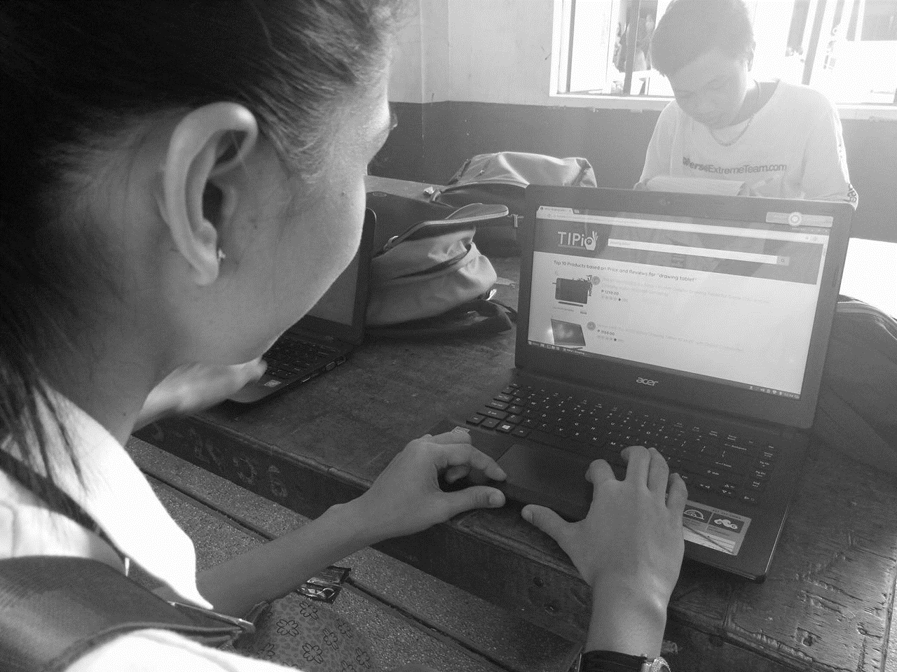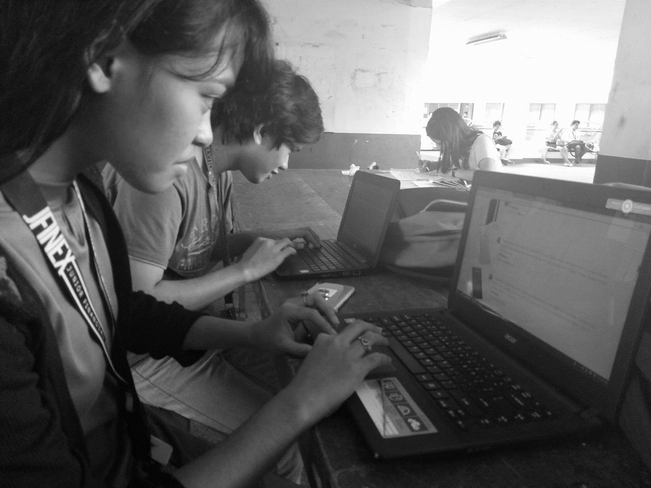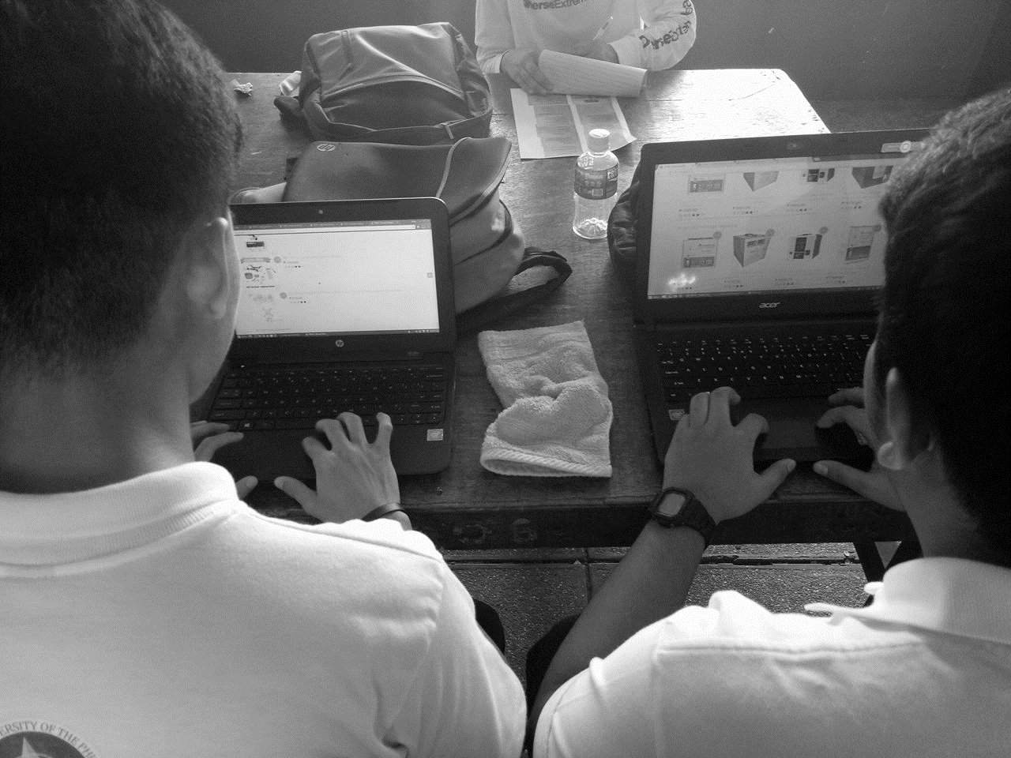

## Appendix C: SCREENSHOTS OF THE SYSTEM

Figure 3. Screenshot of TIPid Homepage

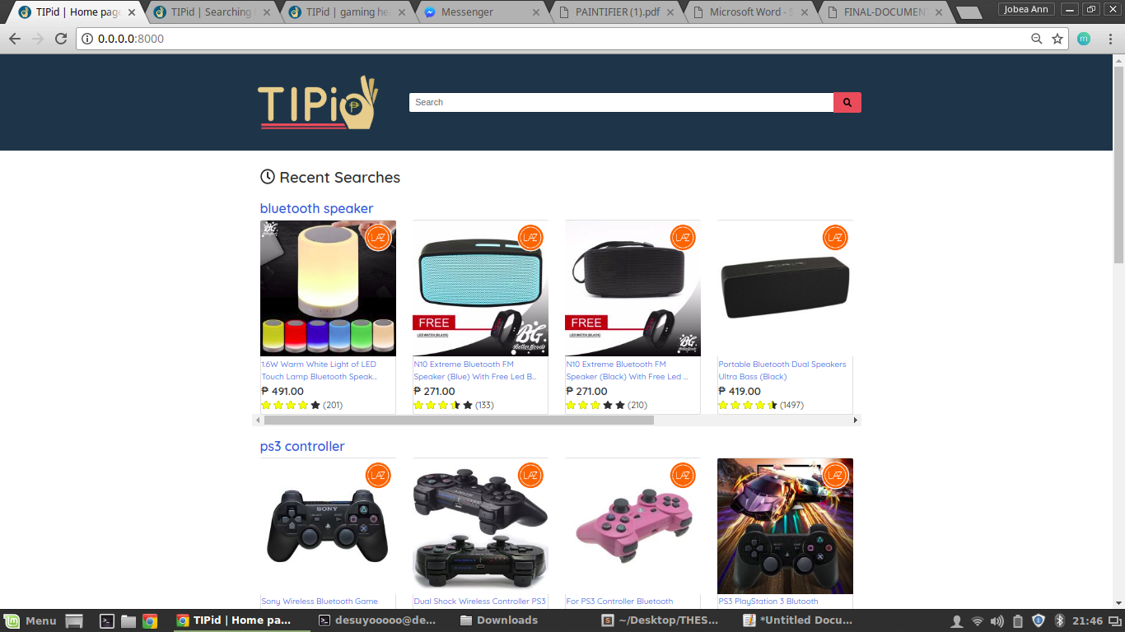

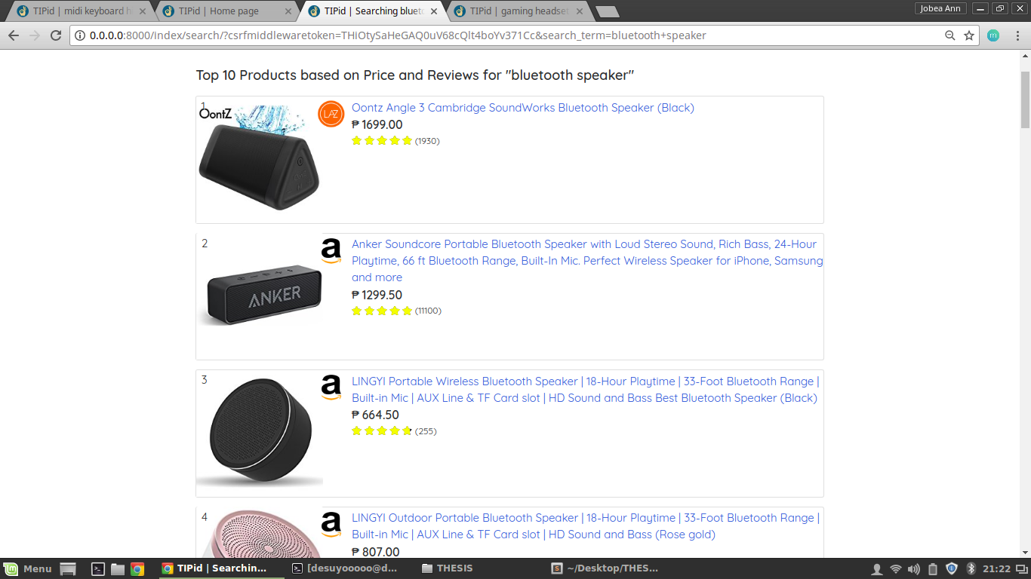Figure 4. Top 10 Best Deals Section in Search Results Page

Figure 5. Top 10 Products based on Price Section

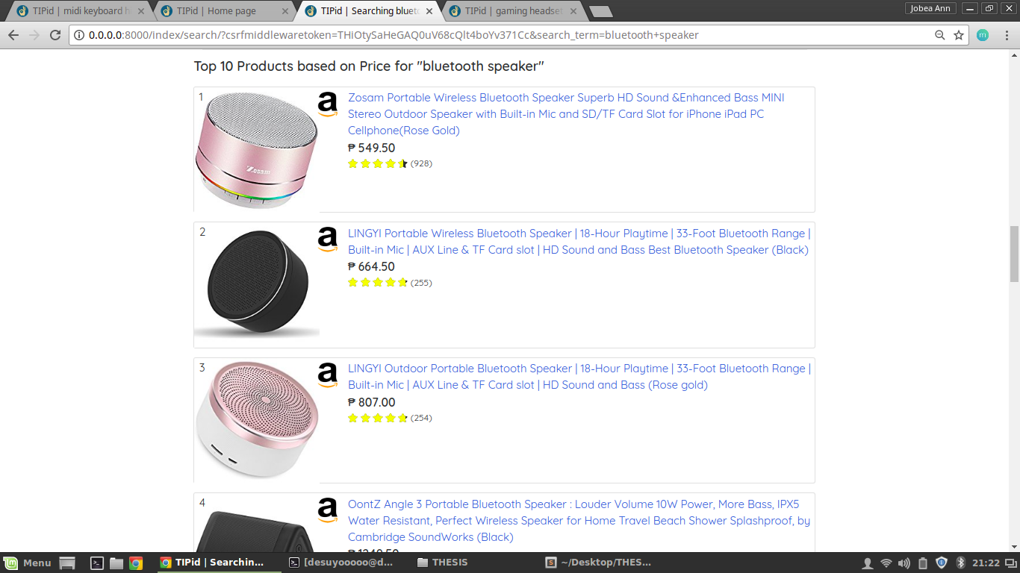

Figure 6. Top 10 Products based on Customer Reviews Section

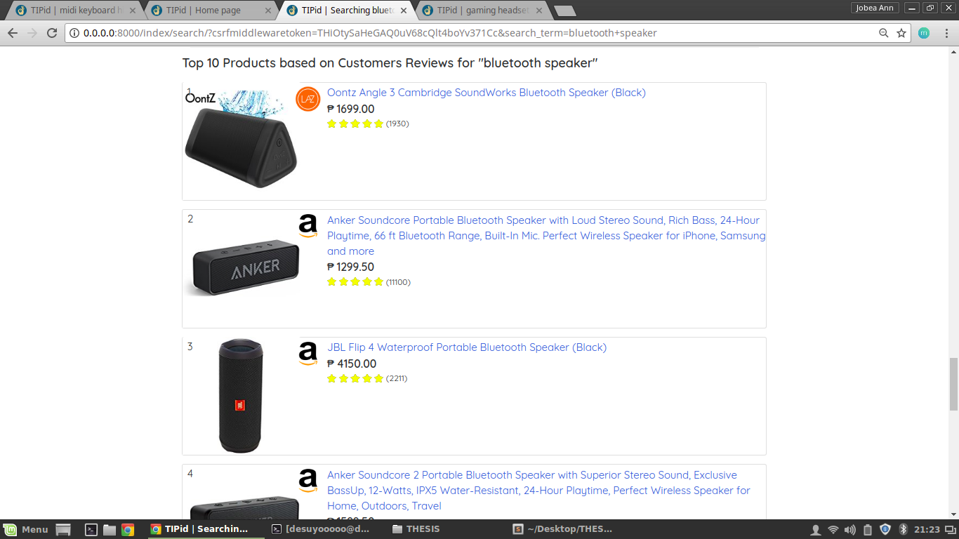

## Appendix D: RESUME OF THE RESEARCHERS

CHRISTIAN AVEROS

5 South 17 Fr. Martinez St. Barangay Obrero, Quezon City

[christianaveros@gmail.com](mailto:christianaveros@gmail.com)

**PERSONAL INFORMATION**

Date of Birth: January 27, 1998

Civil Status: Single

Place of Birth: Quezon City  
Sex: Male  
Languages Spoken: English, Filipino (Tagalog)

**EDUCATIONAL ATTAINMENT**

**Polytechnic University of the Philippines** 2014 – Present

Bachelor of Science in Computer Science

Major in Computer Graphics and Visualization

Sta. Mesa, Manila

**Manuel A. Roxas High School** 2010 -- 2014

With specialization in Metal Welding

Roxas, Quezon City

**SKILLS**

**Microsoft Office:** Word, Power Point

**Programming/Scripting Languages:** C, C#, SQL, Java, HTML, PHP, CSS, JavaScript, CSS, Game Maker Language (GML)

**Multimedia:** Adobe Photoshop, Adobe Flash, Photography, Basic Videography, Basic Animation

**HONORS/AWARDS**

**Top 10 Finalist DevCon Devise: A Student App Development Competition**

PLDT TelTEC InnoLab, 721 Boni Ave. Mandaluyong City (2017)

**Top Participant Bluemix Challenge: #Apps4SocialGood Edition Competition**

IBM Philippines (BGC Office) 28/F, One World Place, 32nd St., BGC, Taguig City (2016)

**WORK EXPERIENCE**

Save22, Inc.  
Unit 1501, Centerpoint Bldg., Julia Vargas Ave., cor. Garnet Rd., Ortigas Center, Pasig City  
I.T/Engineering Department - Intern

Jobea Ann F. Delicano   
10 Khalid St. Kingsville subd. Antipolo City, Rizal

09558553254 / [jobea.delicano@gmail.com](mailto:jobea.delicano@gmail.com)

PERSONAL INFORMATION

Date of Birth: June 21, 1998 Sex: Female

Place of Birth: Pasig City Citizenship: Filipino

Languages Spoken: English and Filipino

EDUCATIONAL ATTAINMENT

2014 – Present Polytechnic University of the Philippines  
College of Computer and Information Sciences  
Bachelor of Science in Computer Science  
Major in Computer Graphics and Visualization  
Sta. Mesa, Manila

2011 – 2014 Roosevelt College Cainta  
Sumulong Highway, Cainta, Rizal

SKILLS

Microsoft Office: Word, Excel, Powerpoint, Publisher

Multimedia: Adobe Photoshop, Adobe Flash, Hitfilm Express

Programming: Python (Django, BeautifulSoup), JavaScript (React, ReactNative, NodeJS), PHP, C, C#, Java, SQL, HTML, CSS

WORK EXPERIENCE

Save22, Inc.  
Unit 1501, Centerpoint Bldg., Julia Vargas Ave., cor. Garnet Rd., Ortigas Center, Pasig City  
I.T/Engineering Department - Intern